CMSC 203

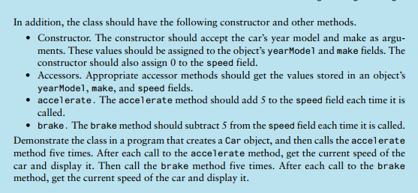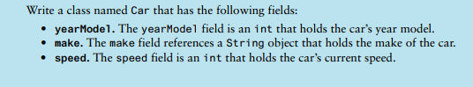Practice writing a Class